

**ASSIGNMENT #3**

**MAINFRAME DEVELOPMENT**

**SUBMITTED BY:**

**NAVJOT SINGH**

**SUBMITTED TO:**

**PROF. STEPHEN SENTER**

**STRUCTURE CHART**

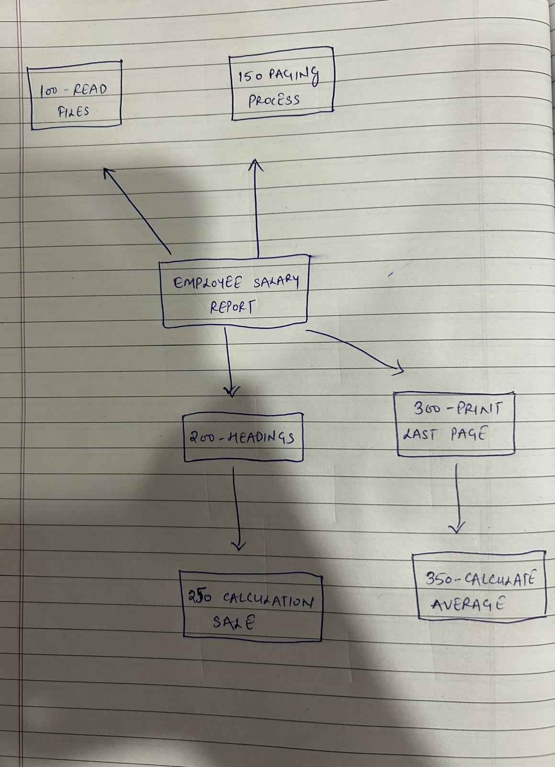

1. **Employee Salary Report:** Main program that controls the full execution of reading, processing, and printing salary data.
2. **100-read-files:** Opens input/output files and reads employee records from the input file.
3. **150-page-process:** Processes each employee's data including salary, position, and percentage increase.
4. **200-headings:** Prints report titles, headings, and page numbers.
5. **250-calculation-sale:** Calculates employee position and salary increase based on education and years of service.
6. **300-print-last-page:** Prints the final summary or average section at the end of the report.
7. **350-calculate-average:** Calculates and displays average salary or other statistics at the end of the report.